Task 23

# Deep Das

1. Encrypt a message using the Caeser-Cipher Method in Python.

Answer:

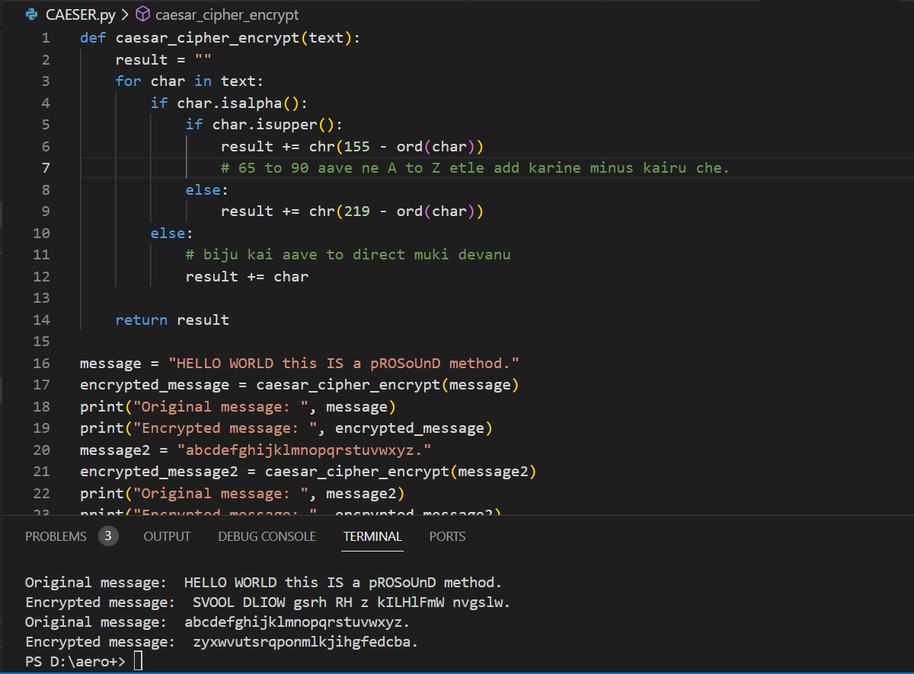

2.create a scatter plot in MATLAB.

Answer:

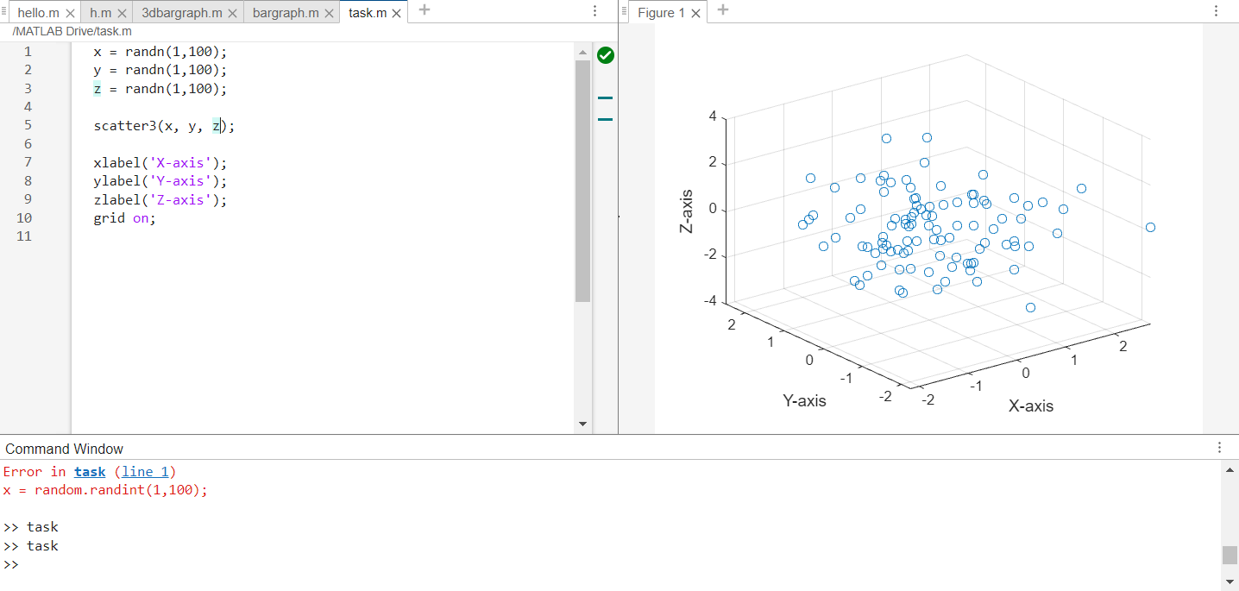

3. Pattern printing.

Answer:

def pattern1():

    n = 5

    for i in range(1, n + 1):

        for iterator in range(n - i):

            print(" ", end="")

        for j in range(1, i + 1):

            print(j, end="")

        for j in range(i - 1, 0, -1):

            print(j, end="")

        print()

    for i in range(n - 1, 0, -1):

        for iterator in range(n - i):

            print(" ", end="")

        for j in range(1, i + 1):

            print(j, end="")

        for j in range(i - 1, 0, -1):

            print(j, end="")

        print()

pattern1()

print()

def pattern2():

    n=5

    for i in range(n):

        print(" "*(n-i-1)+"1",end="")

        if i>0:

            print(" "*(2*i-1)+str(i+1),end="")

        print()

    for i in range(1,n):

        print(" "*i+"1",end="")

        if i<4:

            print(" "*(2*(n-i-1))+str(n-i))

pattern2()

print()

def pattern3():

    rows=6

    for i in range(rows):

        start = 0 if i%2==0 else 1

        string=""

        for j in range (i):

            if j%2==0:

                string += str(start)

            else:

                string += str(1-start)

        print(string)

pattern3()

print()

def pattern4():

     n = 5

     for i in range(1, n + 1):

         for iterator in range(n - i):

             print(" ",end=" ")

         for j in range(1, i + 1):

             print(j,end=" ")

         for j in range(i - 1, 0, -1):

             print(j,end=" ")

         print()

     for i in range(n - 1, 0, -1):

         for iterator in range(n - i):

             print(" ", end=" ")

         for j in range(1, i + 1):

             print(j, end=" ")

         for j in range(i - 1, 0, -1):

             print(j, end=" ")

         print()

pattern4()

print()

def pattern5():

    n=5

    for i in range(5):

        str=''

        for j in range(1,n-i+1):

            if i%2==0:

                str+=('1')

            else:

                str+=('0')

        print(str)

pattern5()

print()

def pattern6():

    n=4

    matrix = [[0]*n for _ in range(n)]

    left, right = 0, n-1

    top, bottom = 0, n-1

    num = 1

    while left <= right and top <= bottom:

        #top row

        for i in range(left, right+1):

            matrix[top][i] = num

            num += 1

        top += 1

        #right column

        for i in range(top, bottom+1):

            matrix[i][right] = num

            num += 1

        right -= 1

        #bottom row

        for i in range(right, left-1, -1):

            matrix[bottom][i] = num

            num += 1

        bottom -= 1

        #left column

        for i in range(bottom, top-1, -1):

            matrix[i][left] = num

            num += 1

        left += 1

    for row in matrix:

        first_cell = True

        row_str = ""

        for cell in row:

            if first_cell==False:

                row_str += " "

            row_str += str(cell)

            first_cell = False

        print(row_str)

pattern6()

output :

